

Ref. No.: SRG/TDS/QE/2019 Rev. No.: 00

TECHNICAL DATA SHEET

QUINONE ETHER (QE)

Synonyms: | Quinol Ether; O,O'-bis(1,3,5-tri-tert-butyl-4-oxo-2,5-cyclohexadienyl)-p-benzoquinone dioxime
CAS No.: | 52211-69-5
Molecular Formula: | C₄₂H₆₂N₂O₄
Avg Mass: | 658.95 g/mol
IUPAC Name: | 2,5-Cyclohexadiene-1,4-dione, 1,4-bis[O-[1,3,5-tris(1,1-dimethylethyl)-4-oxo-2,5-cyclohexadien-1-yl]oxime]

SPECIFICATIONS FOR
Quinone/Quinol Ether (QE)

Sr. No. | Characteristics | Specified Value
1. | Appearance | Powder from light yellow to dark yellow color. A green hue is allowed
2. | Melting Point, °C | 163 - 165
3. | Mass fraction of volatile substances, % | 0.1 max
4. | Mass fraction of tri-tert-butyl-phenol (P-23), % | 0.3 max
5. | Mass fraction of p-dinitroso benzene (p-DNB), % | 0.3 max
6. | Mass fraction of manganese, % | 0.02 max
7. | Solubility in ethyl acetate at ratio  m_{Quinone Ether} : m_{ethyl acetate} = 5.0 : 95.0 | Clear solution No insoluble residue

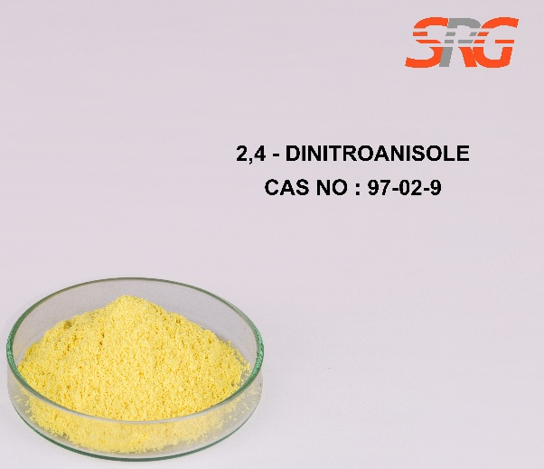


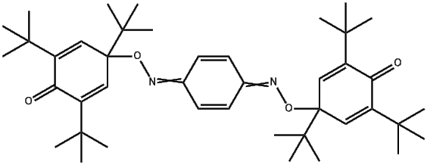


QUINONE ETHER (QE)
CAS No.: 52211-69-5

