

Ref. No.: SRG/TDS/TNSTAD/2022 Rev. No.: 00

TECHNICAL DATA SHEET

1, 4, 5, 8-TETRANITROSO-1, 4, 5, 8-TETRAAZADECALIN (TNSTAD - C2)

An off-white high energy material which is a potential energetic compound, TNSTAD is used for low flame temperature and high force constant gun propellants having great properties like high nitrogen content, low oxygen balance and generation of large number of low molecular weight fractions upon initiation. Further, it has properties like high impact insensitivity compared to conventional compound used in gun propellant. It finds usage in Fin Stabilized Armor Piercing Discarding Sabot (FSAPDS) and other composite propellant formulations.
Synonyms: | Tetra Nitroso Tetra Azadecalin (TNSTAD)
CAS No.: | 81898-35-3
Molecular Formula: | C₆H₁₀N₈O₄
Avg Mass: | 258.19 g/mol
IUPAC Name: | 1,4,5,8-Tetranitrosodecahydropyrazino[2,3-b] pyrazine

SPECIFICATIONS FOR
TNSTAD - C2

Sr. No. | Characteristics | Specified limits
1. | Appearance | White or slightly yellowish wet crystalline powder
2. | Moisture Content, % | 30.0 min
3. | Decomposition Temperature, °C | 202 – 210
4. | Insoluble Material in Acetone, % | 0.8, max
5. | Ash, % | 0.2, max
6. | Particle Size, µm | 10.9 max
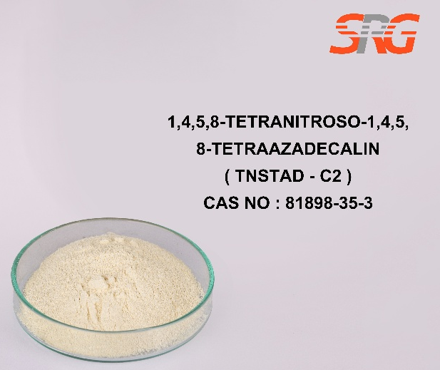
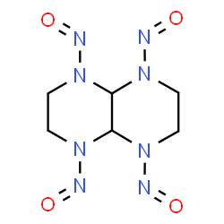





Speciality Products Research Group offers the information contained in this technical data sheet solely for your information. We believe that all the information on this sheet is correct at the time of printing, but we make no warranty as to the accuracy of the data.

