

Ref. No.: SRG/TDS/TNPG/2022 Rev. No.: 00

TECHNICAL DATA SHEET

TRI NITRO PHLORO GLUCINOL (TNPG)

Trinitrophloroglucinol (TNPG or 2,4,6-trinitro-1,3,5-benzenetriol) is a highly nitrated aromatic compound which serves as a precursor or derivative in chemical synthesis and used in applications such as military weapon fuzes or as an initiator for Percussion caps in small caliber ammunition (bullets).
Synonyms: | 2,4,6-Trinitro-1,3,5-benzenetriol
CAS No.: | 4328-17-0
Molecular Formula: | C₆H₃N₃O₉
Avg Mass: | 261.10 g/mol
IUPAC Name: | 2,4,6-trinitrobenzene-1,3,5-triol

SPECIFICATIONS FOR
TRI NITRO PHLORO GLUCINOL (TNPG)

Sr No: | Characteristics | Specified Limits
1 | Appearance | Fine Yellow Powder free from dark material
2 | Water Content of wet material, % by mass | 20 – 25
3 | TNPG Content (dry material), % by mass | 98% min
4 | Melting Point ° C | 160 – 163
5 | Insoluble matter @ 25°C in:  Water, Ethanol methanol | Nil
6 | Soluble matter @ 25°C % by mass in  - Carbon Tetrachloride  - Benzene | 0.05 max  1.55 max
7 | Nitrates, % | Nil
8 | Chloride calculated as Sodium Chloride, % | 0.05 max
9 | pH of 10% aq. extract | 1.60 – 2.10
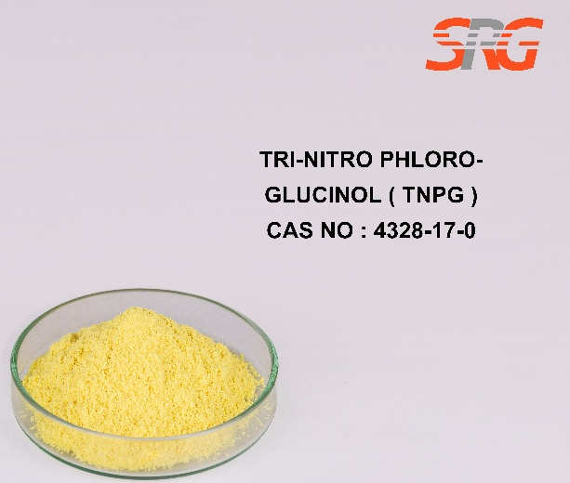
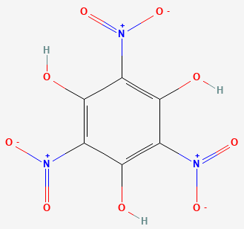




Speciality Products Research Group offers the information contained in this technical data sheet solely for your information. We believe that all the information on this sheet is correct at the time of printing, but we make no warranty as to the accuracy of the data.

