
Ref. No.: SRG/TDS/TADA/2023 Rev. No.: 00

TECHNICAL DATA SHEET

2,6,8,12-Tetraacetyl-2,4,6,8,10,12- Hexaazaisowurtzitane (TADA/TAIW)

Tetraacetyldiamino Hexaazaisowurtzitane (TAIW/TADA) is an intermediate precursor used in the synthesis CL-20 (aka Hexanitrohexaazaisowurtzitane or HNIW.) TADA-based CL-20 co-crystal exhibits low sensitivity to shock and temperature, making it compliant with IM (Insensitive Munitions) requirements.
Synonyms: | 2,6,8,12-tetraacetyl-2,4,6,8,10,12-hexaazatetracyclo] dodecane
CAS No.: | 181940-38-5 / 182763-60-6
Molecular Formula: | C₁₄H₂₀N₆O₄
Avg Mass: | 336.346 g/mol
IUPAC Name: | 1-(6,8,12-triacetyl-2,4,6,8,10,12-hexazatetracyclododecan-2-Yl)ethanone

SPECIFICATIONS FOR TADA

Sr No | Properties | Specification Limits
1. | Appearance | Off white crystalline powder free from grit/particles
2. | Water content % by KF | 0.1% max
3. | Melting Point, °C,  heating rate 10°C/min in N2 | 290 min
4. | Solubility | Soluble in water
5. | Purity by HPLC | 95 - 98% min

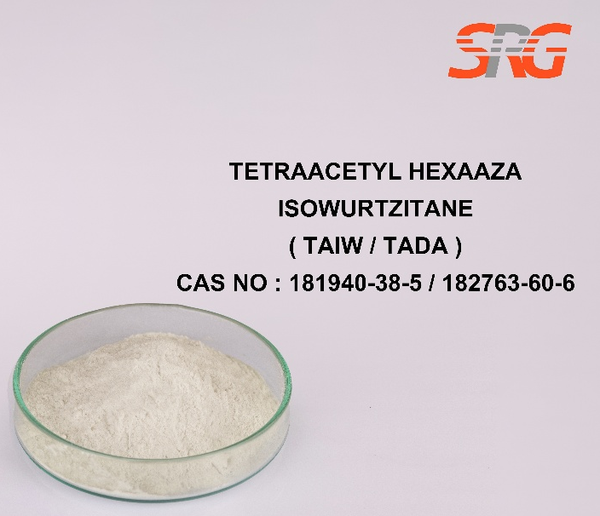
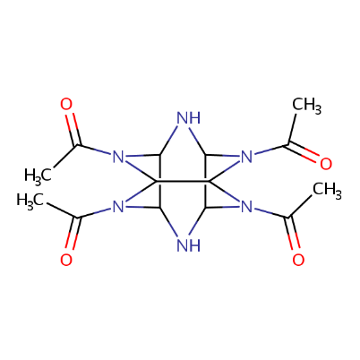




Speciality Products Research Group offers the information contained in this technical data sheet solely for your information. We believe that all the information on this sheet is correct at the time of printing, but we make no warranty as to the accuracy of the data.

