

Ref. No.: SRG/TDS/TPECH/2020 Rev. No.: 00

TECHNICAL DATA SHEET

TETRA FUNCTIONAL POLY-EPICHLOROHYDRIN

Tetra Functional Poly-Epichlorohydrin is used in the synthesis of hydroxyl-terminated glycidyl azide polymer (GAP). This polymer finds use in cast-cured ‘polymer-bonded explosive’ as well as cast-cured composite propellants and in gas generating compositions.
Synonyms: | Epoxidized Poly-Epichlorohydrin
CAS No.: | NA
Molecular Formula: | (C₃H₅O₂)₂(C₃H₅O₂Cl)_{n}
Avg Mass: | >1150.00 g/mol
IUPAC Name: | NA

SPECIFICATIONS FOR
Tetra Functional Poly-Epichlorohydrin (T-PECH)

Sr. No. | Characteristics | Specified Limits
1. | Appearance | Clear Liquid
2. | Physical State | Viscous Liquid
3. | Odour | Mild Odour
4. | pH | Neutral
5. | Volatile Matter, % | <0.1
6. | Moisture content, % | <0.1
7. | Hydroxyl value, mg of KOH | 85 ± 2
8. | Average Mol Wt | >1150
9. | Viscosity, @ 30°C, cP | 9200 – 9600

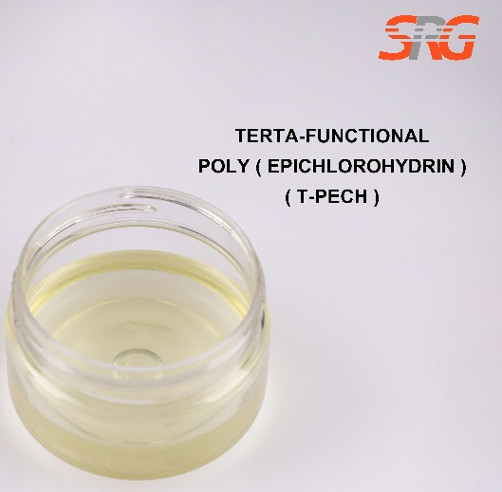

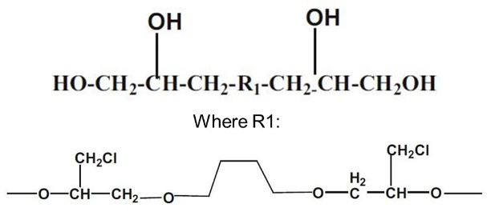




Speciality Products Research Group offers the information contained in this technical data sheet solely for your information. We believe that all the information on this sheet is correct at the time of printing, but we make no warranty as to the accuracy of the data.

