

Ref. No.: SRG/TDS/TGAP/2022 Rev. No.: 00

TECHNICAL DATA SHEET

TETRA FUNCTIONAL GLYCIDYL AZIDE POLYMER

Tetra Functional Glycidyl Azide Polymer (t-GAP) finds use in cast-cured ‘polymer-bonded explosive’ as well as cast-cured composite propellants and in gas generating compositions. Energetic binder such as t-GAP confers higher energy output when compared with non-energetic conventional binder like HTPB
Synonyms: | Tetrafunctional Glycidyl Azide Polymer
CAS No.: | 143178-24-9
Molecular Formula: | (C₃H₅O₂)₂(C₃H₅O₂N₃)_{n}
Avg Mass: | >1900.00 g/mol

SPECIFICATIONS FOR
Tetra Functional Glycidyl Azide Polymer (T-GAP)

Sr. No. | Characteristics | Specified Value
1. | Appearance | Brown/Amber Color liquid
2. | OH Value, mg KOH/gm | 80 ± 5
3. | Specific Gravity at 30°C | 1.3 ± 0.3
4. | Viscosity at 30°C, cP | 1500 - 2000
5. | Molecular Weight (VPO), Daltons | 1800 - 2000
6. | Nitrogen Content, % | 40 ± 2
7. | Moisture Content, %, Max. | 0.5
8. | Volatile Matter, %, Max. | 0.5

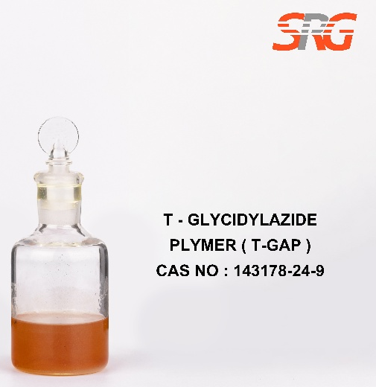

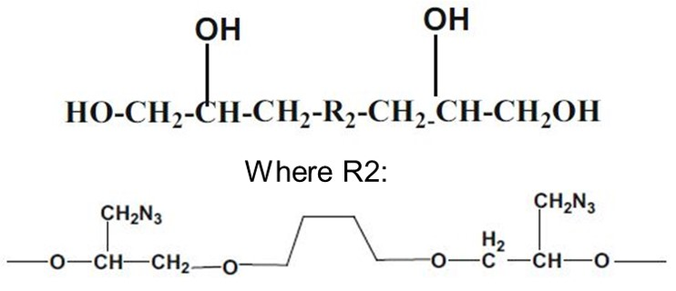




Speciality Products Research Group offers the information contained in this technical data sheet solely for your information. We believe that all the information on this sheet is correct at the time of printing, but we make no warranty as to the accuracy of the data.

