

Ref. No.: SRG/TDS/TNSTAD/2022 Rev. No.: 00

TECHNICAL DATA SHEET

4,6-DIHYDROXY-2-METHYLPYRIMIDINE (4,6-DMP)

4,6-Dihydroxy-2-methylpyrimidine is used in the synthesis of 4,6-dihydroxy-5,5-dinitro-2-(dinitromethylene)-2,5-dihydropyrimidine, which is subsequently hydrolyzed to create 1,1-diamino-2,2-dinitroethylene (often known as FOX-7).
Synonyms: | 2-Methylpyrimidine-4,6-diol
CAS No.: | 40497-30-1
Molecular Formula: | C₅H₆N₂O₂
Avg Mass: | 126.115 g/mol
IUPAC Name: | 6-Hydroxy-2-methyl-4(1H)-pyrimidinone

SPECIFICATIONS FOR
4,6-DIHYDROXY-2-METHYLPYRIMIDINE (4,6-DMP)

Sr. No. | Characteristics | Specified limits
1. | Appearance | White to Light yellow to Light orange powder to crystal
2. | Moisture Content, % | < 0.5%
3. | Melting point, °C | >300
4. | Purity, % | >96.0

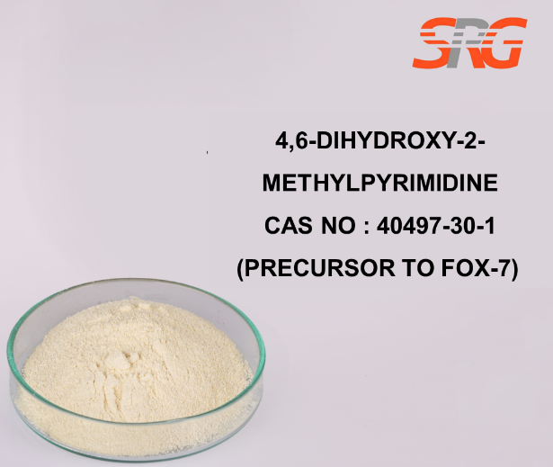
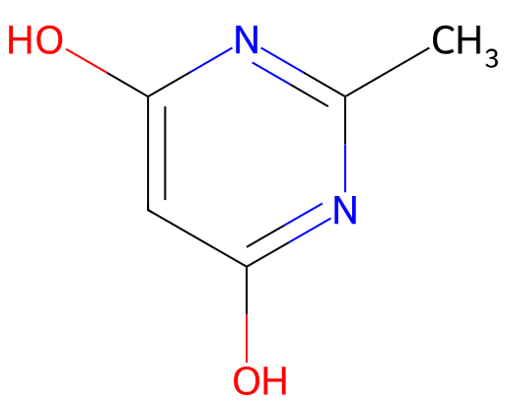





Speciality Products Research Group offers the information contained in this technical data sheet solely for your information. We believe that all the information on this sheet is correct at the time of printing, but we make no warranty as to the accuracy of the data.

