

Ref. No.: SRG/TDS/24DNT/2025 Rev. No.: 00

TECHNICAL DATA SHEET

2,4-DINITROTOLUENE (2,4-DNT)

2,4-Dinitrotoluene (DNT) or dinitro is an organic compound well known as a precursor to trinitrotoluene (TNT) and also is mainly used as a precursor to toluene diisocyanate.
Synonyms: | 2,4-DNT, 2,4-dinitrotoluol, benzene, 1-methyl-2,4-dinitro-
CAS No.: | 121-14-2
Molecular Formula: | C₇H₆N₂O₄
Avg Mass: | 214.13g/mol
IUPAC Name: | 1-methyl-2,4-dinitrobenzene

SPECIFICATIONS FOR
2,4-DINITROTOLUENE (2,4-DNT) as per A-A-59256 or MIL-D-204A

Sr. No. | Characteristics | Specified Limits
1. | Appearance/Colour | Light yellow through Buff powder
2. | Solidification point, °C | 68.0
3. | Acidity as sulfuric acid, % | 0.01 max
4. | Alcohol or benzene insoluble, % | 0.01 max
5. | Moisture and volatile matter, % | 0.25 max
6. | Granulation through a U.S. Number 16 sieve, parts | 95


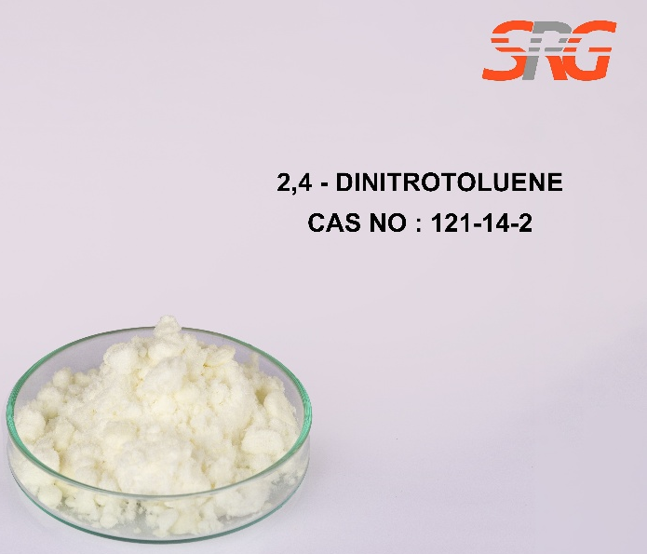





Speciality Products Research Group offers the information contained in this technical data sheet solely for your information. We believe that all the information on this sheet is correct at the time of printing, but we make no warranty as to the accuracy of the data.

