

Ref. No.: SRG/TDS/TO/2025 Rev. No.: 00

TECHNICAL DATA SHEET

1,2-Dihydro-3H-1,2,4-triazol-3-one (TO)

1,2-Dihydro-3H-1,2,4-triazol-3-one, commonly nitrated to become 5-nitro-2,4-dihydro-3H-1,2,4-triazol-3-one (NTO), is a high-performance, insensitive military explosive used as a safer alternative to RDX and TNT. NTO is a key component in melt-cast, low-vulnerability ammunition (LOVA), such as IMX-101, designed to withstand fires and impacts.
Synonyms: | 2,4-Dihydro-3H-1,2,4-triazol-3-one
CAS No.: | 930-33-6
Molecular Formula: | C₂H₃N₃O
Avg Mass: | 85.06 g/mol
IUPAC Name: | 1,2-dihydro-3H-1,2,4-triazol-3-one

SPECIFICATIONS FOR

1,2-Dihydro-3H-1,2,4-triazol-3-one (TO)

Sr No: | Characteristics | Specified Limits
1 | Appearance | Off-white to light brown powder
2 | Moisture, % | 0.5 max
3 | Purity by HPLC, % | 98.0 min
4 | Melting Point ° C | 173 – 175

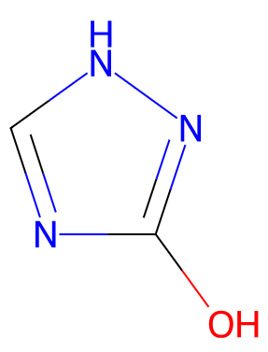
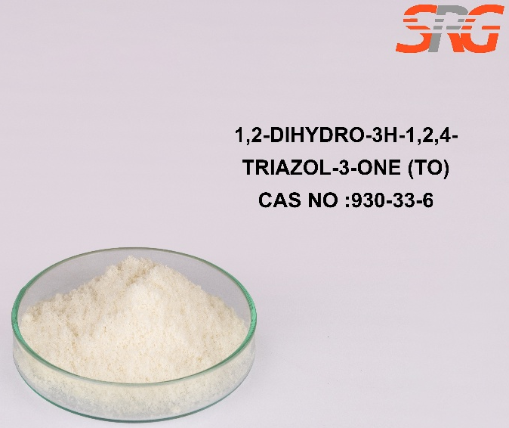





Speciality Products Research Group offers the information contained in this technical data sheet solely for your information. We believe that all the information on this sheet is correct at the time of printing, but we make no warranty as to the accuracy of the data.

