

Ref. No.: SRG/TDS/DNPA/2025 Rev. No.: 00

TECHNICAL DATA SHEET

DNPA
Di-Normal Propyl Adipate

Manufactured as per MIL-D-22346B dated March 19, 1973 specification

CAS No: | 106-19-4
Synonyms: | Di-N Propyl Adipate
Molecular Formula: | C₁₂H₂₂O₄
Avg Mass: | 230.3 g/mol
IUPAC Name: | Dipropyl Hexanedioate

SPECIFICATION FOR DI-NORMAL PROPYL ADIPATE (DNPA)
as per MIL-D-22346B dated March 19, 1973
Sr. No. | Properties | Specification Limits
1 | Acidity, % | 0.1 max.
2 | Ester content, % | 99.0 min.
3 | Specific gravity @ 20/20°C | 0.972 – 0.982
4 | Freezing Point, °C | -19 to -13
5 | Refractive index @ 25°C | 1.4290 – 1.4298
6 | Color | APHA 30 or natural water white
7 | Ash, % | 0.002 max
8 | Saponification Number (AS-3028E) | 450 – 490

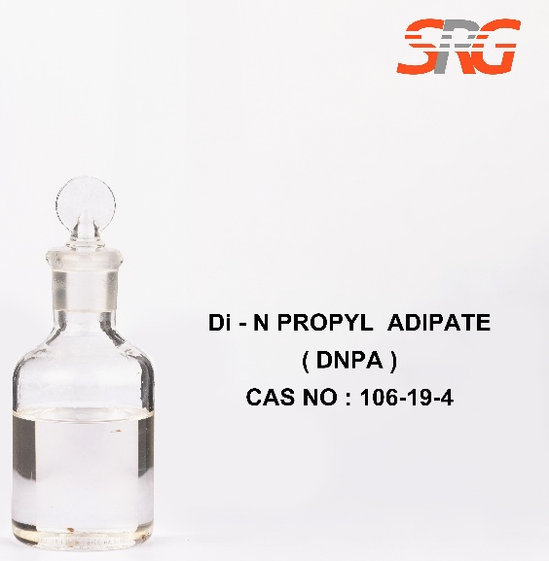

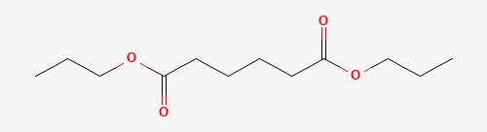




Speciality Products Research Group offers the information contained in this technical data sheet solely for your information. We believe that all the information on this sheet is correct at the time of printing, but we make no warranty as to the accuracy of the data.

