

Ref. No.: SRG/TDS/M-LBR/2015 Rev. No.: 00

TECHNICAL DATA SHEET

MONOBASIC LEAD BETA RESORCYLATE (MLBR)

CAS No: | 20936-32-7
Synonyms: | Lead Beta Resorcylate
Molecular Formula: | C₇H₅O₄Pb
Avg Mass: | 360.3 g/mol
IUPAC Name: | Lead 2,4-dihydroxybenzoate

SPECIFICATION FOR
MONOBASIC LEAD BETA RESORCYLATE

Sr. No. | Properties | Specified Limits
1 | Appearance | Light Buff coloured Powder
2 | Lead Content, % | 56±2.0
3 | Free acidity as Acetic Acid, % | 0.5 Max.
4 | Volatile Matter at 105°C, % | 0.2 Max.
5 | Water Soluble Sulphates | 0.05 Max.
6 | Particle Size | < 75 µm
7 | Water soluble Chloride as NaCl | 0.05 Max.

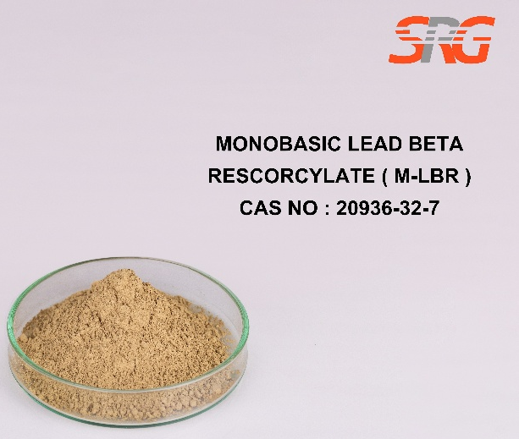
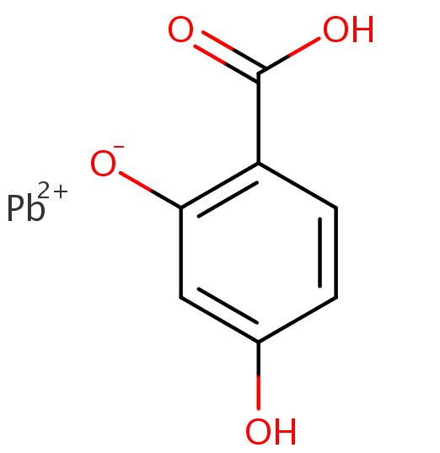



Speciality Products Research Group offers the information contained in this technical data sheet solely for your information. We believe that all the information on this sheet is correct at the time of printing, but we make no warranty as to the accuracy of the data.

