

Ref. No.: SRG/TDS/MCBR/2022 Rev. No.: 00

TECHNICAL DATA SHEET

Copper Beta Resorcylate
(Monobasic Copper Beta Resorcylate)

CAS No: | 70983-44-7
Synonyms: | Monobasic Copper Beta Resorcylate, Benzoic acid, 2,4-dihydroxy-, copper salt, basic
Molecular Formula: | C₁₄H₁₀CuO₈
Avg Mass: | 369.772 g/mol
IUPAC Name: | Copper(2+) bis(2,4-dihydroxybenzoate)

SPECIFICATION FOR COPPER BETA RESORCYLATE
Manufactured as per BC-3C005 specification
Sr. No. | Properties | Specified Limits
1 | Appearance | Fine Powder
2 | Color | Brownish Grey
3 | Copper Content, % | 26.0 min.
4 | Volatile Matter, % | 4.5 max.
5 | Acidity, mg KOH/gm | 30.0 max.
6 | Particle Size, micron | < 2.0

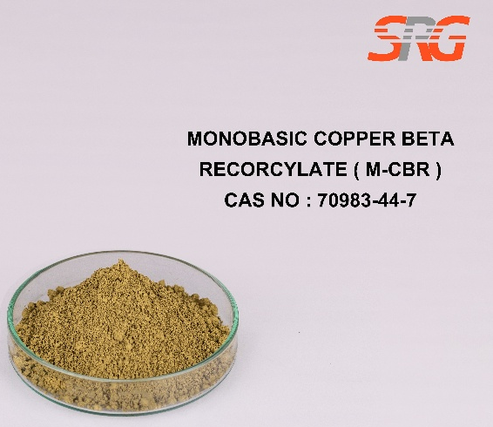

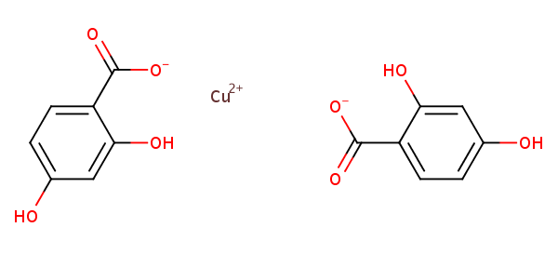




Speciality Products Research Group offers the information contained in this technical data sheet solely for your information. We believe that all the information on this sheet is correct at the time of printing, but we make no warranty as to the accuracy of the data.

