

Ref. No.: SRG/TDS/LS/2015 Rev. No.: 00

TECHNICAL DATA SHEET

LEAD SALICYLATE (LS)

CAS No: | 15748-73-9
Synonyms: | Lead disalicylate,  Lead, bis(2-(hydroxy-kappaO)benzoato-kappaO)  Salicylic acid, lead(II) salt
Molecular Formula: | C₁₄H₁₀O₆Pb
Avg Mass: | 481.0 g/mol
IUPAC Name: | bis(2-carboxyphenolate); lead (2+)

SPECIFICATION FOR
LEAD SALICYLATE (LS) AS PER MIL-L-17700

Sr. No. | Properties | Specified Limits
1 | Appearance | Cream-white to pure white powder
2 | Lead Content, % | 42.2 – 43.7
3 | Total Salicylate Content, % | 55.0 – 59.0
4 | Volatile Matter at 105°C, % | 1.0 max.
5 | Moisture, % | 1.0 max
6 | Diethylene Glycol Insoluble Material, % | 2.50 max.
7 | Free Salicylic Acid Content, % | 1.0 max
8 | Retention on No. 325 Sieve, % | 0.5 max

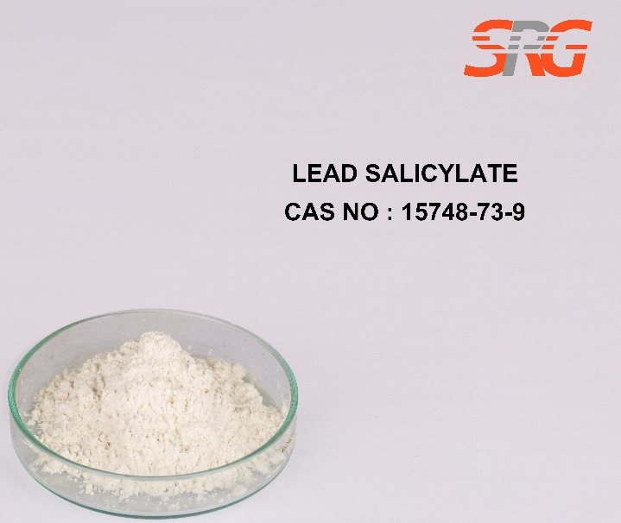

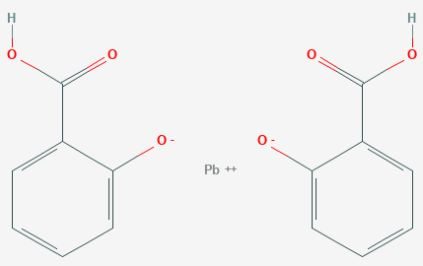




Speciality Products Research Group offers the information contained in this technical data sheet solely for your information. We believe that all the information on this sheet is correct at the time of printing, but we make no warranty as to the accuracy of the data.

