

Ref. No.: SRG/TDS/LCs/2015 Rev. No.: 00

TECHNICAL DATA SHEET

LEAD COPPER COMPLEX – LC-12-15, LC-12-10, LC-12-6

CAS No: | 68411-07-4
Synonyms: | Copper Lead Resorcylate Salicylate Complex
Molecular Formula: | C₁₄H₁₄CuO₆Pb
Avg Mass: | 549.0 g/mol
IUPAC Name: | 2,4-dihydroxybenzoic acid 2-hydroxybenzoic acid copper plumbane

SPECIFICATION FOR
LEAD COPPER COMPLEX – LC-12-15, LC-12-10, LC-12-6

Sr. No. | Characteristics | Specified Limits
Sr. No. | Characteristics | LC-12-15 | LC-12-10 | LC-12-6
1 | Appearance | Green powder | Green powder | Green powder
2 | Copper, % | 10.1 – 12.9 | 9.9 – 12.7 | 9.5 – 12.3
3 | Lead, % | 35.8 – 39.4 | 18.7 – 35.1 | 33.7 – 37.3
4 | B- Resorcylic Acid,% | 11.0 – 16.6 | 24.5 – 30.1 | 35.0 – 40.6
5 | Salicylic Acid, % | 34.5 – 39.7 | 21.8 – 27.0 | 10.6 – 15.8
6 | Oven Dry Loss, (2 hrs @ 105°C), % | 4.0 max | 4.0 max | 4.0 max
7 | Acetone Solubes | 2.0 max | 2.0 max | 2.0 max
8 | Average Particle Size, um | 8 | 8 | 8

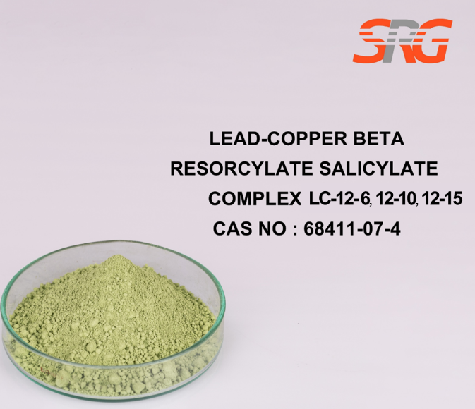
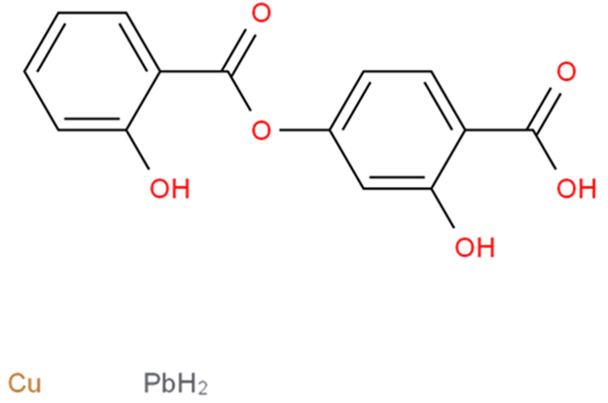



Speciality Products Research Group offers the information contained in this technical data sheet solely for your information. We believe that all the information on this sheet is correct at the time of printing, but we make no warranty as to the accuracy of the data.

