

Ref. No.: SRG/TDS/L2EH/2022 Rev. No.: 00

TECHNICAL DATA SHEET

LEAD 2-ETHYLHEXOATE
Manufactured as per MIL-L-17699 (Nord) specification

CAS No: | 301-08-6
Synonyms: | Lead(II) 2-ethylhexanoate  Lead bis(2-ethylhexanoate)  Hexanoic acid, 2-ethyl-, lead(2+) salt
Molecular Formula: | C16H30O4Pb
Avg Mass: | 494 g/mol
IUPAC Name: | bis(2-ethylhexanoate);lead(2+)

SPECIFICATION FOR
LEAD 2-ETHYL HEXOATE as per MIL-L-17699 (Nord) dated August 24, 1953
Sr. No. | Properties | Specified Limits
1 | Moisture and volatiles, % | 2.0, max
2 | Alkalinity | NONE
3 | Acidity to phenolphthalein as 2-Ethyl Hexanoic acid, % | 1.2, max
4 | Total lead content, % | 40.5 – 42.5
5 | Viscosity | Z-8, min
6 | Insoluble foreign material, % | 1.0, max
7 | Color | Not darker than 7 by Gardner Standard

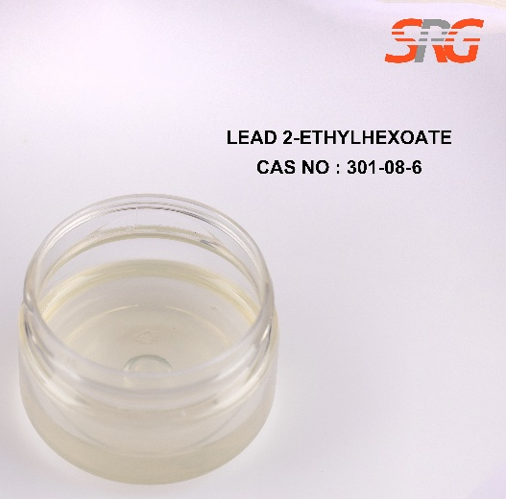

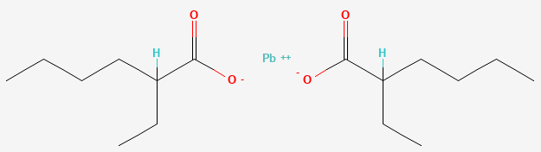




Speciality Products Research Group offers the information contained in this technical data sheet solely for your information. We believe that all the information on this sheet is correct at the time of printing, but we make no warranty as to the accuracy of the data.

