

Ref. No.: SRG/TDS/Specs/CS Rev. No.: 00

TECHNICAL DATA SHEET

Monobasic Cupric Salicylate
(Cupric Salicylate)

Manufactured as per AS-3236 specification

CAS No: | 62320-94-9
Synonyms: | Hydroxy(2-hydroxybenzoato-O1,O2)copper
Molecular Formula: | C₇H₄CuO₄
Avg Mass: | 215.651 g/mol
IUPAC Name: | [3-Hydroxy-2-(hydroxy-kappaO)benzoato(2-)-kappaO]copper

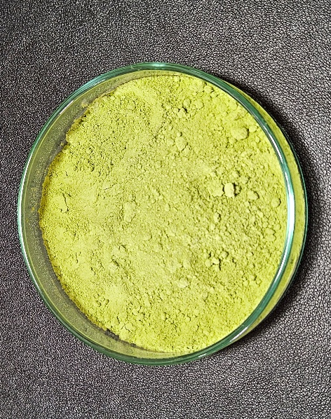
SPECIFICATION FOR
MONOBASIC CUPRIC SALICYALTE as per AS-3236 specifications
Sr. No. | Properties | Specified Limits
1 | Total Lead, % | 39.8 – 40.7
2 | Beta Resorcylic Acid, % | 58.0 – 60.0
3 | Volatile matter, % | 3.0 max.
4 | THF insoluble, % | 1.0 max.
5 | Average particle size, mm | 10

