
Ref. No.: SRG/TDS/MAT/2024 Rev. No.: 00

TECHNICAL DATA SHEET

MAT-O-BOND (MT-4) – ADDUCT OF MAPO

Use | As a propellant binding agent/ cross-linking agent in AP/HTPB composite solid propellants.  As a propellant in Base Bleed Units (BBU)

SPECIFICATION FOR MAT-O-BOND (MT-4)
As per as per ERDL/TRIM/PROP/RM/7
Sr. No. | Properties | Specification Limit
1. | Hydroxyl value (mg KOH/gm) | 370± 30
2. | Acid value (mg KOH/gm) | Max 22
3. | Moisture Content % | 1.0 max
4. | Volatile matter % by mass | 1.0 max

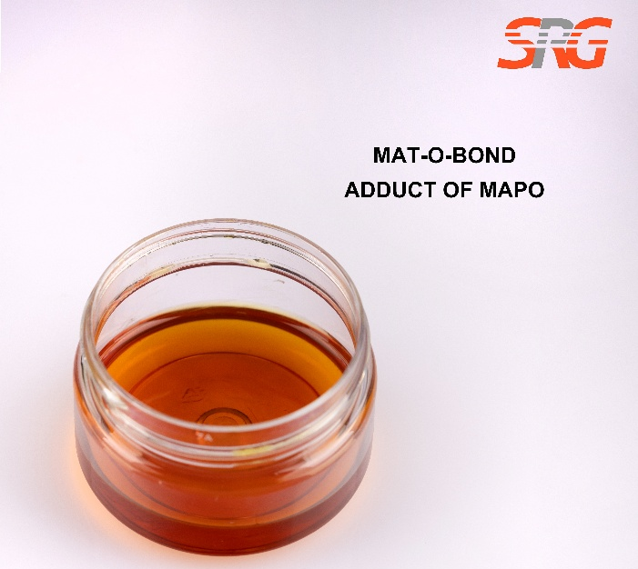




Speciality Products Research Group offers the information contained in this technical data sheet solely for your information. We believe that all the information on this sheet is correct at the time of printing, but we make no warranty as to the accuracy of the data.

