
Ref. No.: SRG/TDS/MAPO/2025 Rev. No.: 01

TECHNICAL DATA SHEET

Tris (1-2 (2-Methyl)) Aziridinyl Phosphine Oxide (MAPO)

CAS No: | 57-39-6
Synonyms: | MAPO/METEPA
Molecular Formula: | C₉H₁₈N₃OP
Avg Mass: | 215.237 g/mol
IUPAC Name: | 1,1',1''-Phosphoryltris(2-methylaziridine)
Uses | As a precursor for manufacture of MT-4 which is a propellant binding agent/ cross-linking agent in AP/HTPB composite solid propellants. As a propellant in Base Bleed Units (BBU)

SPECIFICATION FOR TRIS-1-(2-METHYL AZIRIDINYL) PHOSPHINE OXIDE (MAPO)
As per DOD-T-8266A dated November 6, 1978
Sr. No. | Properties | Specification Limits
Sr. No. | Properties | GRADE A |  | GRADE B
Sr. No. | Properties | Min | Max | Min | Max
1 | Water Content, wt% | - | 0.75 | - | 0.4
2 | Assay, wt % by:  - Imine No.  - Total Phosphorus  - Total Nitrogen | 96.0 | - | 98.0 | -
2 |  | 99.0 | - | 99.0 | -
2 |  | 98.0 | - | 98.0 | -
3 | Total Chlorides, wt % | - | 0.75 | - | 0.20
4 | Hydrolyzable Chlorides, wt% | - | 0.25 | - | 0.10
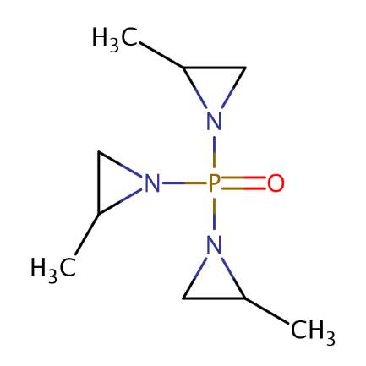
**Note: Hydrolyzable chlorides is as measured using only methanol in the test method
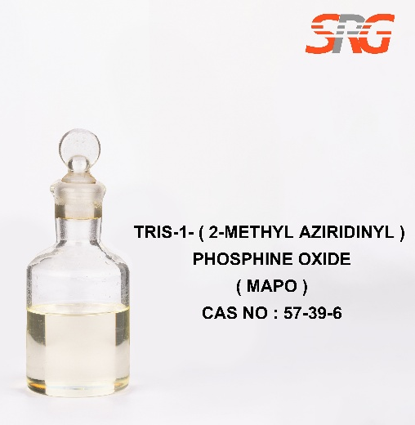




Speciality Products Research Group offers the information contained in this technical data sheet solely for your information. We believe that all the information on this sheet is correct at the time of printing, but we make no warranty as to the accuracy of the data.

