

Ref. No.: SRG/TDS/HX-878/2024 Rev. No.: 00

TECHNICAL DATA SHEET

HX – 878
TEPANOL

CAS No: | 68412- 46-4
Synonyms: | Tepanol, 2-Propenenitrile, reaction products with glycidol and tetraethylenepentamine
Molecular Formula: | C₈H₂₃N₅.C₃H₆O₂.C₃H₃N
Avg Mass: | 316.45 g/mol

SPECIFICATION FOR HX-878
As per MIL-T-82824(OS) dated December 29, 1989
Sr. No. | Properties | Specification Limits
Sr. No. | Properties | Min | Max
1 | Appearance | Viscous Yellow syrup like liquid
2 | Secondary amine content, eq/100 g | 0.5 | 0.7
3 | Total amine content, eq/100 g | 0.8 | 1.2
4 | Tertiary amine content, eq/100 g | 0.3 | 0.5
5 | Hydroxyl content, eq/100 g | 0.4 | 0.6
6 | Moisture, % wt |  | 0.5
7 | Viscosity, cP | 30,000.00 | 60,000.00

***Storage requirement:

- The material is to be stored at -18°C for long shelf life of more than 1 year.
- Pails or drums should be tightly sealed to prevent moisture ingress and placed away from sunlight.
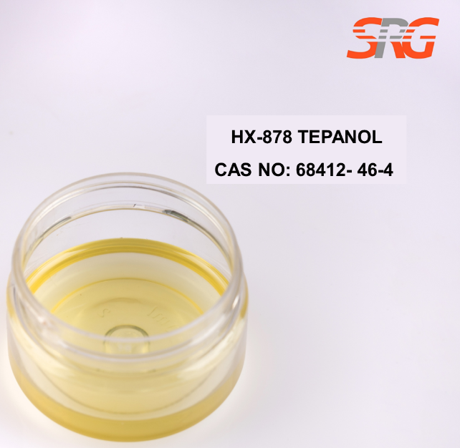

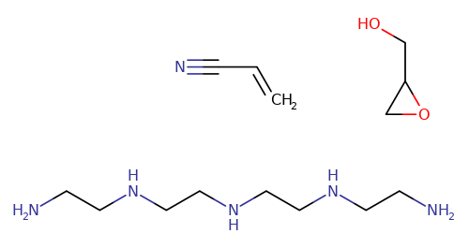





Speciality Products Research Group offers the information contained in this technical data sheet solely for your information. We believe that all the information on this sheet is correct at the time of printing, but we make no warranty as to the accuracy of the data.

