

Ref. No.: SRG/TDS/HX-752/2015 Rev. No.: 00

TECHNICAL DATA SHEET

HX – 752
1,1′-Isophthaloyl- Bis(2-methylaziridine)

CAS No: | 7652-64-4
Synonyms: | HX-752, DIB-752
Molecular Formula: | C₁₄H₁₆N₂O₂
Avg Mass: | 244.294 g/mol

SPECIFICATION FOR HX-752 (TYPE I)
As per MIL-I-85492(AS) dated October 6, 1981
Sr. No. | Properties | Specification Limits
Sr. No. | Properties | Min | Max
1 | Imine equivalent weight, g/g equivalent | 130 | 144
2 | Hydrolyzable chlorine, % wt | --- | 0.9
3 | Moisture, % wt | --- | 0.25
4 | Appearance | Clear or white liquid

***Storage& Transport requirement:

- The material is to be stored at -18°C for long shelf life of more than 1 year.
- For use the whole packet is to be immersed in hot water of not more than 45°C.
- Pails or drums should be tightly sealed to prevent moisture ingress and placed away from sunlight.
- After use tightly seal the pail/drum.


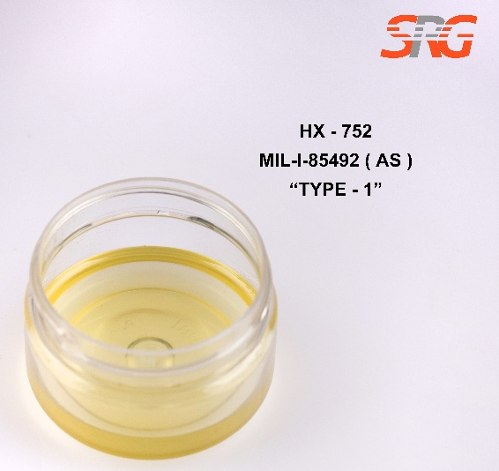
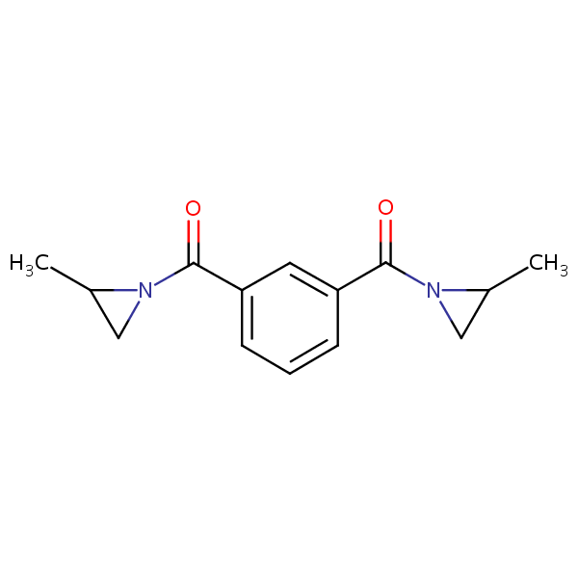
- Transportation strictly in cold containers or insulated containers with dry ice or cold packs.

Speciality Products Research Group offers the information contained in this technical data sheet solely for your information. We believe that all the information on this sheet is correct at the time of printing, but we make no warranty as to the accuracy of the data.

